**Guide for Lectors**

Both Lectors, please check in by initialing the sign-in sheet in the sacristy at least **15 minutes** before Mass begins. You do not want to feel rushed, and the sacristans need to know that you are present so they do not need to look for a last-minute substitute. Check also to see if a deacon will participate in the liturgy and carry the Book of Gospels in the entrance procession (please note, as of 2025, deacons serve at all masses except in rare circumstances). If there is a deacon present, the second lector can proceed to his/her seat in the church in the first two or three pews, close to the center aisle.

Sign-in sheet **(Figure 1),** Announcement binder **(Figure 2)**, Lectionary **(Figure 3)** on the vesting table

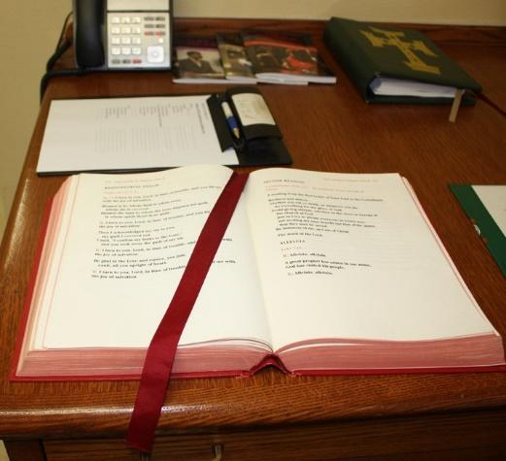

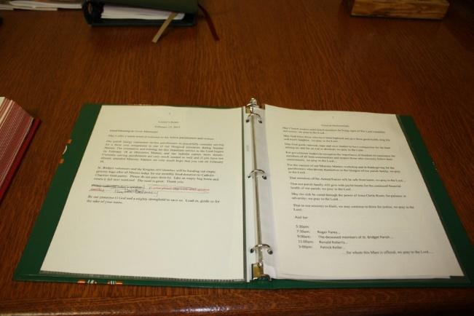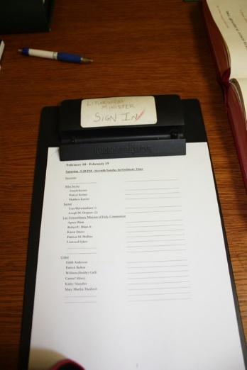

**Figure 1** (Sign-in sheet)

**Figure 2 (**Announcement binder)

**Figure 3** (Lectionary)

**Lector 1:**

Several minutes before the start of Mass, take the announcement binder, the Lectionary, and the Red Book with the Prayers of the Faithful from the Sacristy, going **behind the altar** to the room closest to the ambo, and place them on the top of the ambo, open to the announcements and the first reading, respectively. No bowing is necessary. Be seated on the cantor’s bench **(Figure 4)** behind the piano. Wait until the organist stops playing or the priests enter the back of the church to read the announcements. Then proceed to the ambo.

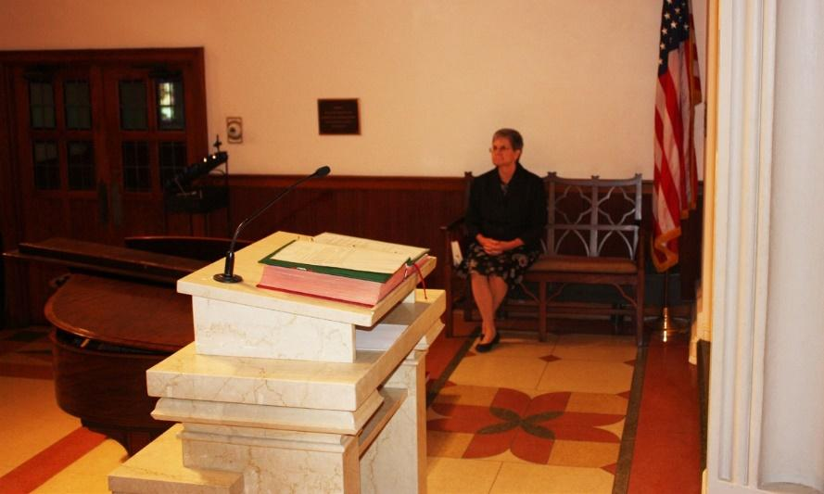

**Figure 4 (Cantor’s bench)**

Check to see if the green light is on at the base of the microphone. DO NOT TAP THE MICROPHONE - the noise disrupts the quiet contemplation of the congregation before Mass. **(Figure 5).**

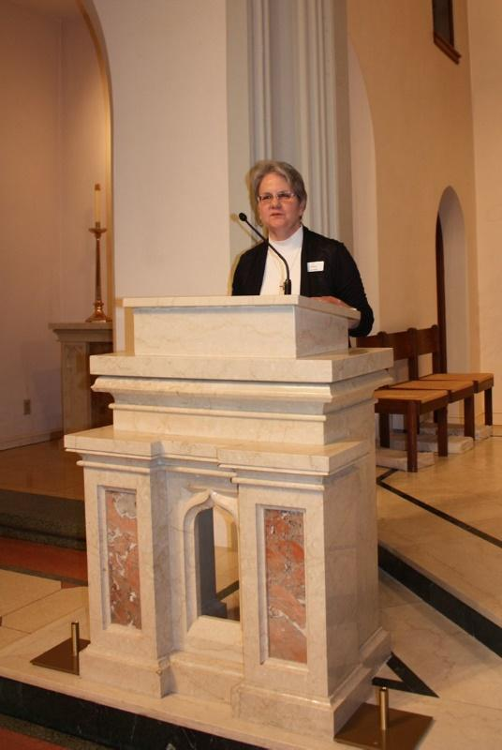

At the priest’s signal, offer the greeting. REMEMBER: The greeting at the beginning is a warm welcome to the congregation. Read it like you are greeting old friends coming to your house. (**Figure 6)**



**Figure 7**

(**Figure 6)** After the greeting is concluded, the entrance procession will begin. Place the announcement binder on an ambo shelf **(Figure 7)**, and return to the cantor’s bench until time for the first reading; do not take the binder back to the cantor’s bench.

Return to the ambo when the priest concludes the opening prayer, which is immediately after the Gloria. ***(NOTE:On Sunday mornings when a Children’s Liturgy of the Word is to take place, the first Lector should return to the ambo when the last few children are about to go out the side door.)*** Pause… and take a breath before beginning your reading. **(Figure 8)** You do not want to appear rushed, and the congregation should be settled and quiet before you start.

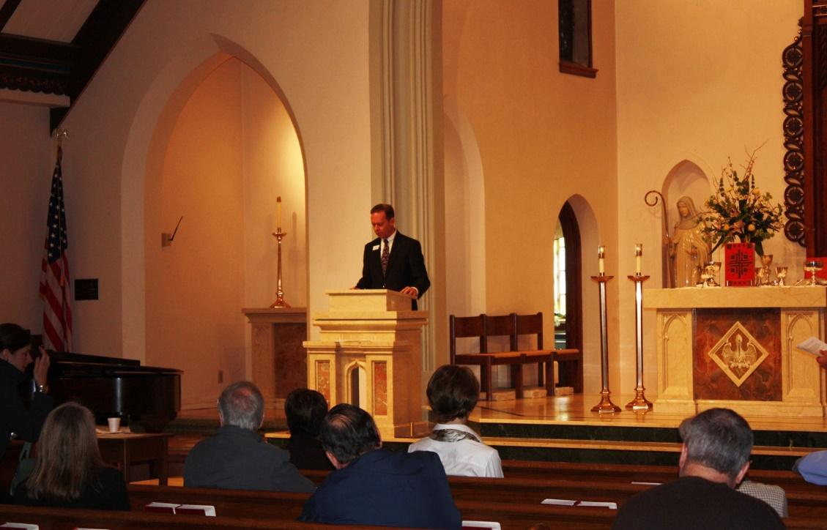 **Figure 8**

After proclaiming the first reading, turn the page to the second reading (if necessary). After a prayerful pause, walk down diagonally from the ambo to the wide landing on the stairs, **(Figure 9)** stopping in the center to bow to the altar, **(Figure 10)** and return to your seat in the congregation. **(Figure 11).**

**Figure 9** 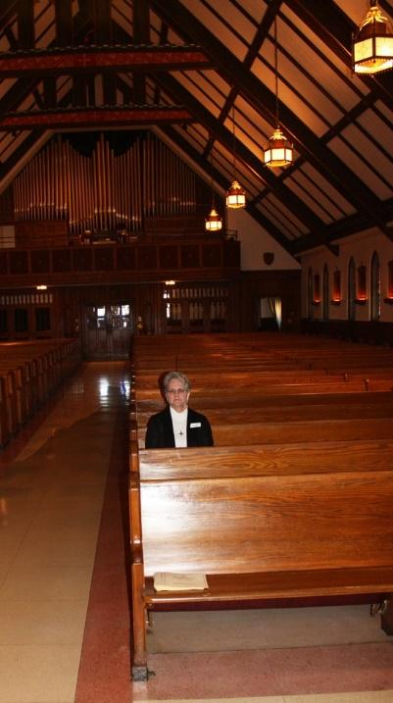

**Figure 11**

**Figure 10 - Bowing**

**Lector 2:**

If there is no deacon and you are to process with the Gospels, ten minutes before Mass, ask the sacristan where the Book of the Gospels is (it may be on the ambo, in the Commons, or already in the sacristy). Join the celebrant in the Commons to greet people as they arrive. Before moving into the back of the church with the altar servers and the priest, take the Book of the Gospels from the table in the Commons **(Figure 12)**.



**Figure12**

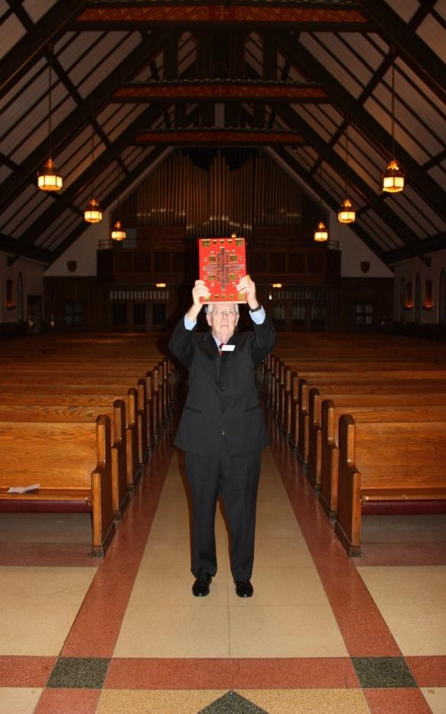

**Figure 13**

Hold the Book of the Gospels high (**Figure 13)** so the congregation will see the reverence that you have for the Word of God! Walk directly up the center of the altar steps, without bowing, and lay the Book of the Gospels on the altar **(there is no longer a plastic holder as seen in Figure 14).**

Come back down the center steps without bowing (the priest will let you pass), and then take your seat in the congregation (ideally in one of the first three pews, along the center aisle).

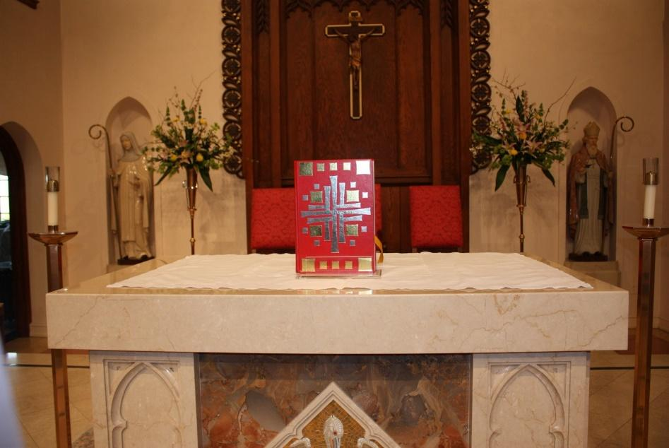

**Figure 14**

You should stand during the last note of the final refrain of the responsorial psalm. Then head toward the altar, pausing to bow in the center of the wide landing on the stairs (**Figure 15)** before turning slightly

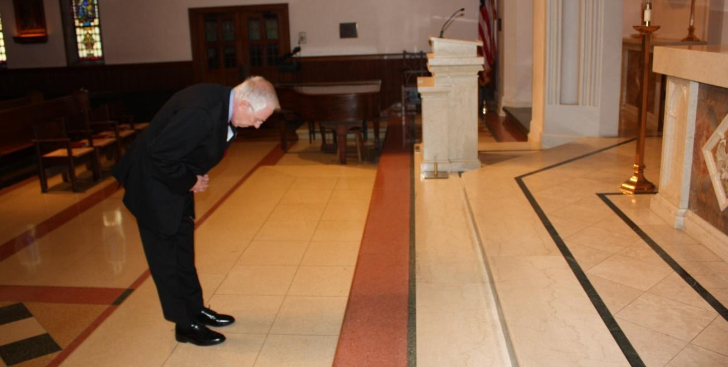

**Figure 15 - Bowing**

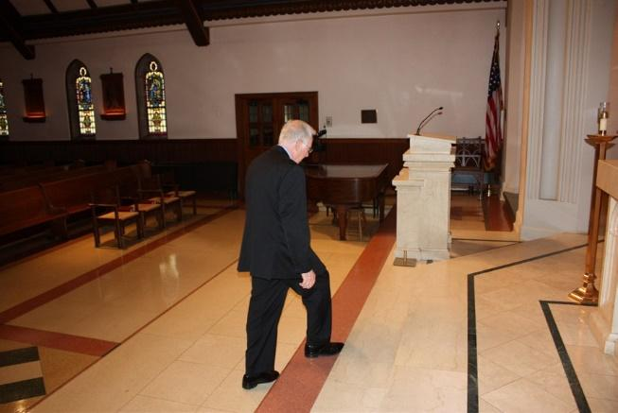

**Figure 16 Figure 17 Figure 18**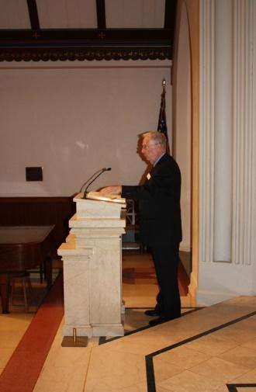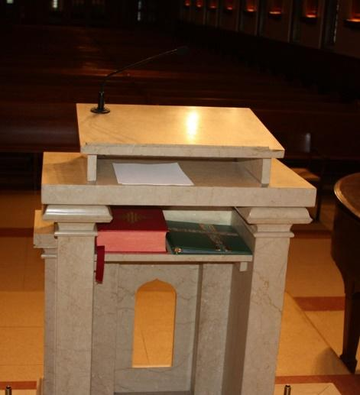

to walk diagonally up to the top step. Then continue toward the ambo, stepping down as you reach the ambo. (**Figure 16)** Check that the green light on the microphone is on before you begin reading; do not rush. After proclaiming the second reading (**Figure 17)**, close and place the Lectionary on an ambo shelf (**Figure 18)** (don’t cover homily notes!), so the priest will have room for the Book of the Gospels on the top of the ambo.

If there is no deacon, after you do the second reading, you will take a seat on the cantor’s bench. After the homily and the Creed, you will deliver the Prayers of the Faithful which can be found in the Red Book that should be on the table in the sacristy before Mass. Lector one needs to put it on a shelf in the ambo when he brings out the other books.

Go to the ambo when the priest finishes his introduction to these prayers. You should not be moving toward the ambo during the priest’s prayer. After you deliver the Prayers of the Faithful, you should stay at the ambo turning slightly toward the priest until he concludes them. Return to your seat after the priest finishes, stopping in the middle of the wide landing to bow to the altar before going up the aisle.

**Notes and Exceptions**

If only one lector is present, you will perform the duties of both lectors as described above (the sacristan will carry the Book of the Gospels in the entrance procession), sit at the cantor’s bench during the responsorial psalm, and then proclaim the second reading. You will return to the cantor’s bench until after the homily and the Creed; then deliver the Prayers of the Faithful, and return to your seat as above. **Please always be prepared to proclaim both readings, just in case!**

For any questions, contact the one of the parish Lector Coordinators:  
 Betty Drozeski: (804) 314-0936 or [bettdro@aol.com](mailto:bettdro@aol.com)  
 Elizabeth Spach: [ems7ka@virginia.edu](mailto:ems7ka@virginia.edu)

Jeff Lunardi: [jefflunardi@gmail.com](mailto:jefflunardi@gmail.com)

**Helpful Tips for Lectors**

1. Start preparing your reading the week before you are scheduled to read. Review all three readings, including the gospel, to get a feel for the theme of the week’s liturgy, and read the commentary and margin notes for each in the Lectors Workbook. Find the rhythm or tempo in each reading. Practice your reading out loud daily.

2. Be prepared to proclaim both readings, in case the other lector does not come.

3. As a general rule to help you remember when to approach the ambo, do not walk when the priest is praying. Wait for him (or the music of the responsorial psalm) to end, and do not rush getting to the ambo. Give the congregation a few seconds to get settled before you begin your reading.

4. Point the microphone toward your chin, then forget that you have a microphone to help you and project your voice toward the back of the church. If your voice is really loud, stand slightly back from the ambo. You do not want to speak softly and rely on the microphone to carry your voice, or you will not project the importance of the Word you are proclaiming. Leave the microphone on when you leave the Ambo since most people following you will need it on, and the priest can always turn it off if he does not wish to use it.

5. **Read s l o w l y** - more slowly than feels natural to you. Pause between sentences, and take one full breath at the longer pauses (blank spaces between “paragraphs”) noted in the workbook.

6. Pronounce clearly the consonants at the end of words. (We tend to “swallow” them in natural speech.)

7. Make eye contact with the congregation as you read. Practice reading in front of a mirror, and periodically look up at your reflection. (Caution: do not attempt to memorize your reading so that you look at the congregation all the time.)

8. You are not acting but you should read with expression; read like you are telling a story because the first reading often is a story. Your facial expressions can add a lot to your proclamation as long as they are not overdone.

9. Take a breath after you finish the reading before you pronounce, “the Word of the Lord.” Stand reverently at the ambo and wait for the music to begin before you return to your seat, unless the cantor needs to come to the ambo after you read, then pause only briefly before leaving the ambo.

10. When you are scheduled to read, please wear clothing that reflects your respect and appreciation for the Word of God you are proclaiming. On the other hand, if you are not scheduled to read and are asked to sub on the spur of the moment for a Lector who has not shown up for Mass, do not decline simply because you may be dressed too casually. Please remember however, that immodest clothing is never acceptable for a lector.

11. Even when you are not scheduled to read, try to arrive ten minutes early and check in the Sacristy to be sure both Lectors on the schedule have arrived, in case you are needed as a substitute. The Sacristans will appreciate your willingness to assist if needed.

12. Remember the power of non-verbal communications!

13. A good resource for Lectors is the followin[g: http://www.usccb.org/bible/index.cfm](http://www.usccb.org/bible/index.cfm)